**HUMAN RIGHTS AND GENDER**

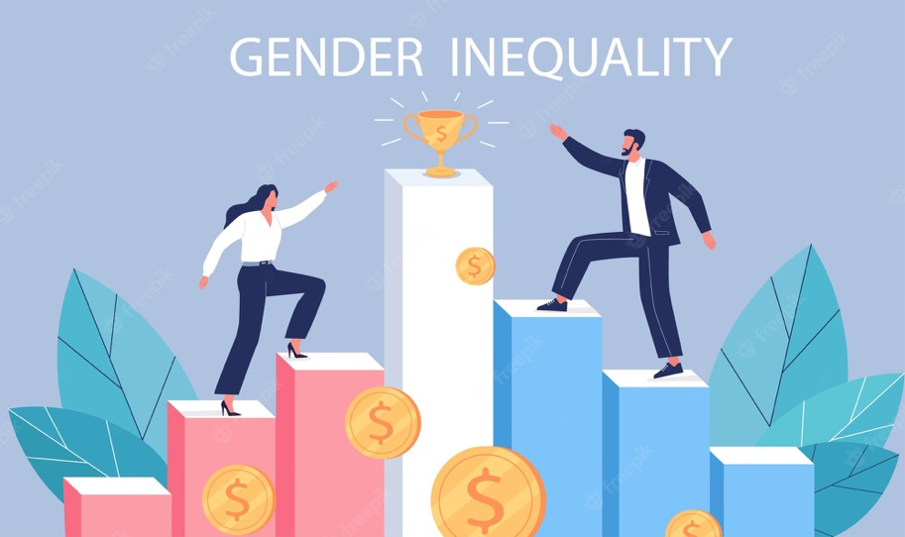

Human rights are the fundamental rights that are inherent to every person, regardless of their race, gender, nationality, religion, or any other status. These rights include the right to life, liberty, and security of a person; the right to education, work, and healthcare; the right to freedom of expression, assembly, and religion; and the right to participate in the political process.

Gender inequality refers to the unequal treatment or discrimination of individuals based on their gender. This can manifest in various ways, such as unequal pay for equal work, limited access to education and employment opportunities, and violence against women.

About women, gender inequality is a pervasive problem affecting women and girls worldwide. Women and girls face discrimination and oppression in various forms, including economic, social, cultural, and political. This can result in a lack of equal opportunities and rights and can have serious consequences for their health, well-being, and overall quality of life.

One of the main areas where gender inequality affects women is in the workplace. Despite significant progress in recent decades, women continue to earn less than men on average and are often underrepresented in leadership positions and certain industries. This is known as the gender pay gap, and it is a widespread problem that exists in many countries. The reasons for the gender pay gap are complex and multifaceted and can include discrimination, bias, and systemic barriers that prevent women from reaching their full potential.

Another area where gender inequality impacts women are in their access to education. In many parts of the world, girls are less likely than boys to receive an education, especially in rural or poverty-stricken areas. This can have serious consequences for their prospects and ability to participate in the economy and society. Girls who do not receive an education are more likely to marry young and have children at a young age, which can lead to a cycle of poverty and reduced opportunities.

Violence against women is another major issue that is closely tied to gender inequality. Women and girls around the world face physical, sexual, and emotional violence at the hands of their partners, family members, and strangers. This violence can have serious physical and psychological consequences for the victims and can have long-lasting effects on their lives. In addition to the direct impact on the victims, violence against women has negative consequences for families, communities, and society.

The good news is that there are steps that can be taken to address and reduce gender inequality and promote gender equality. Governments, civil society organizations, and individuals can all play a role in this effort. For example, governments can enact laws and policies that promote gender equality, such as equal pay for equal work, parental leave policies, and initiatives to promote the education of girls. Civil society organizations can work to raise awareness about gender inequality and advocate for change, while individuals can challenge gender stereotypes and support initiatives that promote gender equality.

*Steps are taken by the Indian government to promote gender equality in India –*

• Beti Bachao Beti Padhao (BBBP)

• Mahila Shakti Kendra.

• Working Women Hostel (WWH)

• Scheme for adolescent girls.

• Mahila Police Volunteers (MPV)

• Rashtriya Mahila Kosh (RMK)

• National crèche scheme for the children of working mothers.

• Pradhan mantri matru vandna yojna.

In conclusion, gender inequality is a pervasive problem affecting women and girls worldwide. It manifests in various ways, including in the workplace, education access, and violence against women. While significant progress has been made in recent decades, there is still much work to be done to promote gender equality and reduce gender inequality. By working together and taking action, we can create a more equal and just society for all people, regardless of their gender.

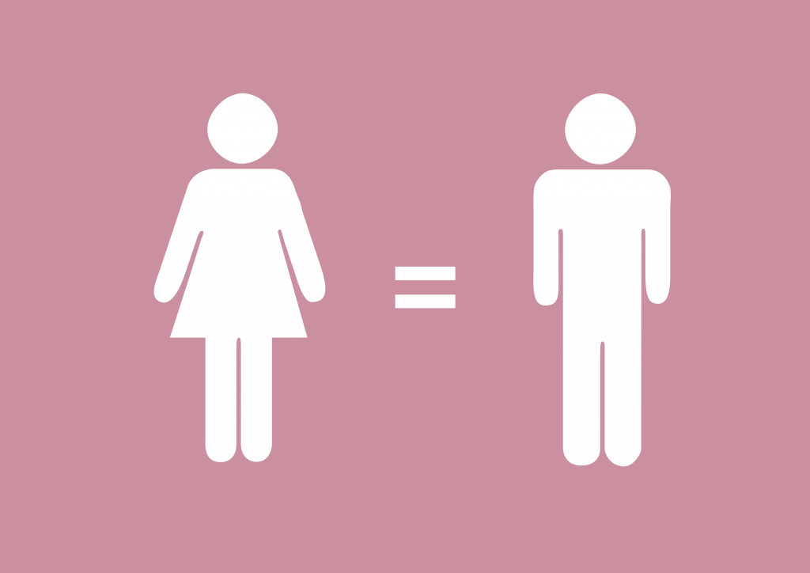

*By-*

**Shivang Gulati**

**CJ – 92**

Reg No. – **220905264**